Dissertation - Analysis

15-04-2024

knitr::opts_chunk$set(echo = TRUE)

setwd("~/Dissertation")  
library(dplyr)

##   
## Attaching package: 'dplyr'

## The following objects are masked from 'package:stats':  
##   
## filter, lag

## The following objects are masked from 'package:base':  
##   
## intersect, setdiff, setequal, union

library(fixest)  
library(lmtest)

## Loading required package: zoo

##   
## Attaching package: 'zoo'

## The following objects are masked from 'package:base':  
##   
## as.Date, as.Date.numeric

library(ggplot2)  
library(psych)

##   
## Attaching package: 'psych'

## The following objects are masked from 'package:ggplot2':  
##   
## %+%, alpha

library(did)

##   
## Attaching package: 'did'

## The following object is masked from 'package:psych':  
##   
## sim

library(Hmisc)

##   
## Attaching package: 'Hmisc'

## The following object is masked from 'package:psych':  
##   
## describe

## The following objects are masked from 'package:dplyr':  
##   
## src, summarize

## The following objects are masked from 'package:base':  
##   
## format.pval, units

library(GGally)

## Registered S3 method overwritten by 'GGally':  
## method from   
## +.gg ggplot2

library(car)

## Loading required package: carData

##   
## Attaching package: 'car'

## The following object is masked from 'package:psych':  
##   
## logit

## The following object is masked from 'package:dplyr':  
##   
## recode

Data cleaning

#Population, Income, and Unemployment data for 2012  
a12<-read.csv2("2012.csv")  
a12 <- a12[, c(4, 5, 20,25,26)]  
names(a12)<-c("ID","Population","Income","Pop15.64", "Unemployed")  
a12$Population<-as.numeric(a12$Population)  
a12$Income<-as.numeric(a12$Income)  
a12$Pop15.64<- as.numeric(a12$Pop15.64)  
a12$Unemployed<-as.numeric(a12$Unemployed)  
  
a12_s <- a12 %>%  
 group_by(ID) %>%  
 mutate(TotalPop = sum(Population, na.rm=TRUE), #Population of each department  
 MedianIncome = mean(Income, na.rm=TRUE), #Mean income each department   
 Unemployed2012=sum(Unemployed, na.rm=TRUE), #Number of unemployed  
 Pop15.64.2012 = sum(Pop15.64,na.rm=TRUE)) %>% #Number of people 15-64  
distinct(ID, .keep_all = TRUE)   
  
unique(a12_s$ID)

## [1] "10" "18" "15" "16" "23" "24" "25" "47" "49" "42" "52" "53"   
## [13] "63" "64" "89" "31" "45" "46" "41" "17" "11" "07" "08" "01"   
## [25] "27" "28" "37" "38" "33" "30" "39" "34" "35" "55" "56" "59"   
## [37] "26" "68" "69" "70" "09" "06" "12" "76" "77" "78" "71" "02"   
## [49] "84" "85" "81" "21" "22" "19" "66" "61" "94" "14" "50" "51"   
## [61] "54" "58" "04" "36" "29" "2B" "73" "62" "03" "32" "95" "974"  
## [73] "88" "82" "83" "91" "973" "74" "80" "40" "57" "65" "72" "05"   
## [85] "44" "60" "13" "67" "93" "2A" "79" "43" "48" "86" "92" "90"   
## [97] "87" "972" "971" "75"

a12_s$ID <- as.character(a12_s$ID)  
a12_s <- a12_s %>%  
 filter(!(ID %in% c("2A", "2B", "971","972", "973", "974"))) #Remove these departments from dataset, only looking at Continental Metropolitan France  
unique(sort(a12_s$ID)) #94 departments remaining

## [1] "01" "02" "03" "04" "05" "06" "07" "08" "09" "10" "11" "12" "13" "14" "15"  
## [16] "16" "17" "18" "19" "21" "22" "23" "24" "25" "26" "27" "28" "29" "30" "31"  
## [31] "32" "33" "34" "35" "36" "37" "38" "39" "40" "41" "42" "43" "44" "45" "46"  
## [46] "47" "48" "49" "50" "51" "52" "53" "54" "55" "56" "57" "58" "59" "60" "61"  
## [61] "62" "63" "64" "65" "66" "67" "68" "69" "70" "71" "72" "73" "74" "75" "76"  
## [76] "77" "78" "79" "80" "81" "82" "83" "84" "85" "86" "87" "88" "89" "90" "91"  
## [91] "92" "93" "94" "95"

a12_s$ID<-as.numeric(a12_s$ID)  
  
a12_s <- a12_s %>%  
 mutate(Unemployment2012 = (Unemployed2012/Pop15.64.2012)*100) #Calculate Unemployment rate   
mean(a12_s$Unemployment2012)

## [1] 9.059924

a12_s <- a12_s[, c(1,6, 7,10)]  
summary(a12_s)

## ID TotalPop MedianIncome Unemployment2012  
## Min. : 1.00 Min. : 76889 Min. :16792 Min. : 5.987   
## 1st Qu.:25.25 1st Qu.: 308564 1st Qu.:18474 1st Qu.: 8.141   
## Median :48.50 Median : 543601 Median :19263 Median : 9.008   
## Mean :48.30 Mean : 670848 Mean :19895 Mean : 9.060   
## 3rd Qu.:71.75 3rd Qu.: 878545 3rd Qu.:20821 3rd Qu.: 9.661   
## Max. :95.00 Max. :2587128 Max. :27685 Max. :13.301

a12_s <- a12_s %>%  
 mutate(Year = 2012) #add year column

b<-read.csv("P1-Controls2017-2022.csv") #load Population, Income, and Unemployment for 2017 and 2022  
b$ID<-as.numeric(b$ID)  
  
b2 <- b[, c(2,3,4,5,6)]  
a12_s <- a12_s %>% select(ID, Year, TotalPop, MedianIncome, Unemployment2012)  
a12_s <- a12_s %>% arrange(ID)  
b2<-b2 %>%select(ID, Y, Population,Income,Unemployment)  
  
colnames(a12_s) <- colnames(b2)  
combined<-rbind(b2, a12_s) # combine datasets

c<-read.csv("Outcome2012-2022.csv") #outcome variables for 2012,2017,2022  
c$ID<-as.numeric(c$ID)  
summary(is.na(c))

## Dep ID Y EM   
## Mode :logical Mode :logical Mode :logical Mode :logical   
## FALSE:282 FALSE:282 FALSE:282 FALSE:188   
## TRUE :94   
## EM.share FN FN.share EELV   
## Mode :logical Mode :logical Mode :logical Mode :logical   
## FALSE:188 FALSE:282 FALSE:282 FALSE:188   
## TRUE :94 TRUE :94   
## EELV.share LR LR.share PS   
## Mode :logical Mode :logical Mode :logical Mode :logical   
## FALSE:188 FALSE:282 FALSE:282 FALSE:282   
## TRUE :94   
## PS.share LFI LFI.share   
## Mode :logical Mode :logical Mode :logical   
## FALSE:282 FALSE:188 FALSE:188   
## TRUE :94 TRUE :94

A<- left_join(c,combined, by=c("ID","Y")) #create one dataset for 2012-2022  
  
e<-read.csv("P2-Controls2012-2022.csv") #remaining controls for all years: immigration, population density, area, education  
e$ID<-as.numeric(e$ID)  
A<-left_join(A,e, by=c("ID","Y","Dep")) # combine  
A <- A %>%  
 mutate(PopDensity = ifelse(Y == 2012 & is.na(PopDensity), (Population/Area), PopDensity)) # calculate population density for 2012   
  
f<-read.csv("Stat-Explanatory2012-2022.csv") #Explanatory variable for 2012-2022  
  
A<-left_join(A,f, by=c("ID","Y","Dep")) # Dataset for 2012-2022 completed

Look at the descriptive statistics of the dataset

describeBy(A,group=A$Y)

## Warning in FUN(newX[, i], ...): no non-missing arguments to min; returning Inf  
## Warning in FUN(newX[, i], ...): no non-missing arguments to min; returning Inf  
## Warning in FUN(newX[, i], ...): no non-missing arguments to min; returning Inf  
## Warning in FUN(newX[, i], ...): no non-missing arguments to min; returning Inf

## Warning in FUN(newX[, i], ...): no non-missing arguments to max; returning -Inf  
## Warning in FUN(newX[, i], ...): no non-missing arguments to max; returning -Inf  
## Warning in FUN(newX[, i], ...): no non-missing arguments to max; returning -Inf  
## Warning in FUN(newX[, i], ...): no non-missing arguments to max; returning -Inf

## Warning in FUN(newX[, i], ...): no non-missing arguments to min; returning Inf  
## Warning in FUN(newX[, i], ...): no non-missing arguments to min; returning Inf

## Warning in FUN(newX[, i], ...): no non-missing arguments to max; returning -Inf  
## Warning in FUN(newX[, i], ...): no non-missing arguments to max; returning -Inf

##   
## Descriptive statistics by group   
## group: 2012  
## vars n mean sd median trimmed mad  
## Dep 1 94 47.50 27.28 47.50 47.50 34.84  
## ID 2 94 48.30 27.56 48.50 48.37 34.84  
## Y 3 94 2012.00 0.00 2012.00 2012.00 0.00  
## EM 4 0 NaN NA NA NaN NA  
## EM.share 5 0 NaN NA NA NaN NA  
## FN 6 94 18.83 4.41 19.07 18.92 5.16  
## FN.share 7 94 0.19 0.04 0.19 0.19 0.05  
## EELV 8 94 2.17 0.59 2.10 2.13 0.53  
## EELV.share 9 94 0.02 0.01 0.02 0.02 0.01  
## LR 10 94 21.24 2.81 20.63 21.10 2.36  
## LR.share 11 94 0.21 0.03 0.21 0.21 0.02  
## PS 12 94 28.09 4.30 27.72 28.01 4.46  
## PS.share 13 94 0.28 0.04 0.28 0.28 0.04  
## LFI 14 0 NaN NA NA NaN NA  
## LFI.share 15 0 NaN NA NA NaN NA  
## Population 16 94 670848.02 502082.00 543601.00 601316.51 374758.28  
## Income 17 94 19894.58 2205.62 19262.71 19553.95 1443.82  
## Unemployment 18 94 9.06 1.41 9.01 9.00 1.15  
## Immigration 19 94 7.09 4.40 6.20 6.41 3.11  
## Education 20 94 11.26 5.59 9.70 10.27 2.82  
## Area 21 94 5694.53 1933.75 5964.26 5883.92 1191.89  
## PopDensity 22 94 571.92 2494.39 85.27 105.20 61.31  
## ImmigrationShare 23 94 0.07 0.04 0.06 0.06 0.03  
## No.Turbines 24 94 10.19 12.57 5.00 8.01 7.41  
## min max range skew kurtosis se  
## Dep 1.00 94.00 93.00 0.00 -1.24 2.81  
## ID 1.00 95.00 94.00 -0.02 -1.23 2.84  
## Y 2012.00 2012.00 0.00 NaN NaN 0.00  
## EM Inf -Inf -Inf NA NA NA  
## EM.share Inf -Inf -Inf NA NA NA  
## FN 6.20 27.03 20.83 -0.21 -0.56 0.45  
## FN.share 0.06 0.27 0.21 -0.21 -0.56 0.00  
## EELV 1.16 4.18 3.02 0.78 0.53 0.06  
## EELV.share 0.01 0.04 0.03 0.78 0.53 0.00  
## LR 14.05 29.08 15.03 0.44 0.22 0.29  
## LR.share 0.14 0.29 0.15 0.44 0.22 0.00  
## PS 18.89 42.97 24.08 0.40 0.53 0.44  
## PS.share 0.19 0.43 0.24 0.40 0.53 0.00  
## LFI Inf -Inf -Inf NA NA NA  
## LFI.share Inf -Inf -Inf NA NA NA  
## Population 76889.00 2587128.00 2510239.00 1.39 1.85 51785.80  
## Income 16792.22 27685.09 10892.87 1.58 2.52 227.49  
## Unemployment 5.99 13.30 7.31 0.40 0.24 0.15  
## Immigration 2.00 28.40 26.40 2.01 5.56 0.45  
## Education 6.00 44.20 38.20 3.20 13.70 0.58  
## Area 105.40 10000.14 9894.74 -1.05 1.74 199.45  
## PopDensity 14.88 21258.26 21243.38 6.70 49.23 257.28  
## ImmigrationShare 0.02 0.28 0.26 2.01 5.53 0.00  
## No.Turbines 0.00 58.00 58.00 1.54 2.07 1.30  
## ------------------------------------------------------------   
## group: 2017  
## vars n mean sd median trimmed mad  
## Dep 1 94 47.50 27.28 47.50 47.50 34.84  
## ID 2 94 48.30 27.56 48.50 48.37 34.84  
## Y 3 94 2017.00 0.00 2017.00 2017.00 0.00  
## EM 4 94 23.15 3.42 22.50 22.93 3.66  
## EM.share 5 94 0.23 0.03 0.22 0.23 0.04  
## FN 6 94 22.54 5.94 22.91 22.65 6.69  
## FN.share 7 94 0.23 0.06 0.23 0.23 0.07  
## EELV 8 0 NaN NA NA NaN NA  
## EELV.share 9 0 NaN NA NA NaN NA  
## LR 10 94 19.52 3.32 18.55 19.20 2.20  
## LR.share 11 94 0.20 0.03 0.19 0.19 0.02  
## PS 12 94 6.11 1.36 5.84 6.01 1.19  
## PS.share 13 94 0.06 0.01 0.06 0.06 0.01  
## LFI 14 94 19.29 3.05 19.38 19.15 2.81  
## LFI.share 15 94 0.19 0.03 0.19 0.19 0.03  
## Population 16 94 707094.05 550244.21 556537.00 627060.24 401140.41  
## Income 17 94 20787.66 1625.31 20425.00 20593.29 985.93  
## Unemployment 18 94 7.26 0.97 7.24 7.23 0.82  
## Immigration 19 94 7.74 4.60 6.80 7.01 3.19  
## Education 20 94 16.01 6.57 14.55 14.96 3.78  
## Area 21 94 5694.53 1933.75 5964.26 5883.92 1191.89  
## PopDensity 22 94 578.98 2467.54 87.83 110.32 66.38  
## ImmigrationShare 23 94 0.08 0.05 0.07 0.07 0.03  
## No.Turbines 24 94 16.14 21.37 7.50 11.96 11.12  
## min max range skew kurtosis se  
## Dep 1.00 94.00 93.00 0.00 -1.24 2.81  
## ID 1.00 95.00 94.00 -0.02 -1.23 2.84  
## Y 2017.00 2017.00 0.00 NaN NaN 0.00  
## EM 17.73 34.83 17.10 0.69 0.33 0.35  
## EM.share 0.18 0.35 0.17 0.69 0.33 0.00  
## FN 4.99 35.67 30.68 -0.21 -0.12 0.61  
## FN.share 0.05 0.36 0.31 -0.21 -0.12 0.01  
## EELV Inf -Inf -Inf NA NA NA  
## EELV.share Inf -Inf -Inf NA NA NA  
## LR 12.75 29.14 16.39 0.86 0.57 0.34  
## LR.share 0.13 0.29 0.16 0.86 0.57 0.00  
## PS 3.44 10.91 7.47 0.84 1.00 0.14  
## PS.share 0.03 0.11 0.07 0.84 1.00 0.00  
## LFI 13.97 34.02 20.05 1.15 4.21 0.31  
## LFI.share 0.14 0.34 0.20 1.15 4.21 0.00  
## Population 76601.00 2604361.00 2527760.00 1.39 1.69 56753.36  
## Income 17310.00 27400.00 10090.00 1.86 5.07 167.64  
## Unemployment 5.07 9.86 4.79 0.32 0.07 0.10  
## Immigration 2.30 30.50 28.20 2.09 6.02 0.47  
## Education 9.10 53.60 44.50 2.99 12.37 0.68  
## Area 105.40 10000.14 9894.74 -1.05 1.74 199.45  
## PopDensity 14.83 20754.52 20739.69 6.53 46.75 254.51  
## ImmigrationShare 0.02 0.31 0.28 2.09 6.04 0.00  
## No.Turbines 0.00 112.00 112.00 2.15 5.32 2.20  
## ------------------------------------------------------------   
## group: 2022  
## vars n mean sd median trimmed mad  
## Dep 1 94 47.50 27.28 47.50 47.50 34.84  
## ID 2 94 48.30 27.56 48.50 48.37 34.84  
## Y 3 94 2022.00 0.00 2022.00 2022.00 0.00  
## EM 4 94 26.89 3.90 26.88 26.64 3.46  
## EM.share 5 94 0.27 0.04 0.27 0.27 0.03  
## FN 6 94 25.07 6.01 25.31 25.25 4.51  
## FN.share 7 94 0.25 0.06 0.25 0.25 0.05  
## EELV 8 94 4.27 1.12 4.03 4.16 1.07  
## EELV.share 9 94 0.04 0.01 0.04 0.04 0.01  
## LR 10 94 4.88 1.07 4.82 4.78 0.86  
## LR.share 11 94 0.05 0.01 0.05 0.05 0.01  
## PS 12 94 1.83 0.53 1.77 1.79 0.50  
## PS.share 13 94 0.02 0.01 0.02 0.02 0.00  
## LFI 14 94 20.17 4.77 19.24 19.55 2.90  
## LFI.share 15 94 0.20 0.05 0.19 0.20 0.03  
## Population 16 94 790520.71 874945.35 556502.00 635484.89 411402.97  
## Income 17 94 22689.15 1732.96 22230.00 22480.00 1208.32  
## Unemployment 18 94 7.05 1.43 6.90 6.92 1.19  
## Immigration 19 94 8.00 4.49 7.15 7.34 2.97  
## Education 20 94 17.28 6.88 15.85 16.21 4.23  
## Area 21 94 5694.53 1933.75 5964.26 5883.92 1191.89  
## PopDensity 22 94 591.54 2441.90 88.84 118.50 68.43  
## ImmigrationShare 23 94 0.08 0.04 0.07 0.07 0.03  
## No.Turbines 24 94 22.77 31.55 10.00 16.55 14.83  
## min max range skew kurtosis se  
## Dep 1.00 94.00 93.00 0.00 -1.24 2.81  
## ID 1.00 95.00 94.00 -0.02 -1.23 2.84  
## Y 2022.00 2022.00 0.00 NaN NaN 0.00  
## EM 19.71 37.11 17.40 0.56 -0.10 0.40  
## EM.share 0.20 0.37 0.17 0.56 -0.10 0.00  
## FN 5.54 39.27 33.73 -0.42 0.95 0.62  
## FN.share 0.06 0.39 0.34 -0.42 0.95 0.01  
## EELV 2.44 7.61 5.17 0.89 0.45 0.12  
## EELV.share 0.02 0.08 0.05 0.89 0.45 0.00  
## LR 2.97 8.61 5.64 1.14 2.12 0.11  
## LR.share 0.03 0.09 0.06 1.14 2.12 0.00  
## PS 0.95 3.52 2.57 0.87 0.97 0.05  
## PS.share 0.01 0.04 0.03 0.87 0.97 0.00  
## LFI 13.76 49.09 35.33 2.81 13.05 0.49  
## LFI.share 0.14 0.49 0.35 2.81 13.05 0.00  
## Population 76633.00 5562651.00 5486018.00 3.60 16.27 90243.72  
## Income 19020.00 29730.00 10710.00 1.92 5.39 178.74  
## Unemployment 4.10 11.70 7.60 0.82 0.56 0.15  
## Immigration 2.40 31.00 28.60 2.17 6.96 0.46  
## Education 9.60 55.80 46.20 2.87 11.45 0.71  
## Area 105.40 10000.14 9894.74 -1.05 1.74 199.45  
## PopDensity 14.83 20359.64 20344.81 6.41 45.10 251.86  
## ImmigrationShare 0.02 0.31 0.29 2.17 6.94 0.00  
## No.Turbines 0.00 184.00 184.00 2.54 8.03 3.25

A2017 <- subset(A, Y == 2017)  
  
# Median in 2017  
median(A2017$Area, na.rm = TRUE)

## [1] 5964.265

median(A2017$Population)

## [1] 556537

A2017t <- subset(A2017, No.Turbines>0)  
# median in 2017 for departments with turbines  
median(A2017t$Area)

## [1] 6039.74

median(A2017t$Population)

## [1] 539067

mean(A2017t$No.Turbines)

## [1] 19.20253

summary(A2017t$No.Turbines)

## Min. 1st Qu. Median Mean 3rd Qu. Max.   
## 1.0 4.0 13.0 19.2 27.5 112.0

Two Way Fixed Effects Analysis

#Front National 2012-2022  
summary(feols(FN~No.Turbines|Dep+Y, data=A, cluster =~Dep)) #0.059

## OLS estimation, Dep. Var.: FN  
## Observations: 282  
## Fixed-effects: Dep: 94, Y: 3  
## Standard-errors: Clustered (Dep)   
## Estimate Std. Error t value Pr(>|t|)   
## No.Turbines 0.058545 0.014744 3.9708 0.00014107 ***  
## ---  
## Signif. codes: 0 '***' 0.001 '**' 0.01 '*' 0.05 '.' 0.1 ' ' 1  
## RMSE: 1.14085 Adj. R2: 0.945915  
## Within R2: 0.172244

summary(feols(FN~No.Turbines+Education+Income+log(PopDensity)+Unemployment+ Immigration|Dep+Y,data=A, cluster=~Dep)) #0.047

## OLS estimation, Dep. Var.: FN  
## Observations: 282  
## Fixed-effects: Dep: 94, Y: 3  
## Standard-errors: Clustered (Dep)   
## Estimate Std. Error t value Pr(>|t|)   
## No.Turbines 0.046638 0.013357 3.491677 0.00073622 ***  
## Education -0.815617 0.271395 -3.005270 0.00341052 **   
## Income 0.000339 0.000121 2.801394 0.00619019 **   
## log(PopDensity) 0.305092 0.193171 1.579388 0.11764252   
## Unemployment -0.688216 0.205055 -3.356242 0.00114551 **   
## Immigration 0.058124 0.098005 0.593073 0.55457199   
## ---  
## Signif. codes: 0 '***' 0.001 '**' 0.01 '*' 0.05 '.' 0.1 ' ' 1  
## RMSE: 0.888776 Adj. R2: 0.966263  
## Within R2: 0.497627

#extract coefficients for ATE figure  
m1 <- tidy(lm(FN~No.Turbines + as.factor(Y)+as.factor(ID), data = A))  
ATE.1 <- m1[m1$term == "No.Turbines", "estimate"]  
se.1 <- m1[m1$term == "No.Turbines", "std.error"]  
ATE.1 <- as.numeric(ATE.1)  
se.1 <- as.numeric(se.1)  
  
reg1 <- tidy(lm(FN~No.Turbines +Education+Income+log(PopDensity)+  
Unemployment+ Immigration+ as.factor(Y)+as.factor(ID), data = A))  
ATE.r1 <- reg1[reg1$term == "No.Turbines", "estimate"]  
se.r1 <- reg1[reg1$term == "No.Turbines", "std.error"]  
ATE.r1 <- as.numeric(ATE.r1)  
se.r1 <- as.numeric(se.r1)  
  
##EELV 2012-2022: but no observations for 2017  
summary(feols(EELV~No.Turbines|Dep+Y, data=A, cluster =~Dep)) #-0.005

## NOTE: 94 observations removed because of NA values (LHS: 94).

## OLS estimation, Dep. Var.: EELV  
## Observations: 188  
## Fixed-effects: Dep: 94, Y: 2  
## Standard-errors: Clustered (Dep)   
## Estimate Std. Error t value Pr(>|t|)   
## No.Turbines -0.005186 0.00197 -2.63247 0.0099255 **   
## ---  
## Signif. codes: 0 '***' 0.001 '**' 0.01 '*' 0.05 '.' 0.1 ' ' 1  
## RMSE: 0.34629 Adj. R2: 0.871477  
## Within R2: 0.025148

summary(feols(EELV~No.Turbines+Education+Income+log(PopDensity)+ Unemployment+Immigration|Dep+Y,data=A, cluster=~Dep)) # insignificant

## NOTE: 94 observations removed because of NA values (LHS: 94).

## OLS estimation, Dep. Var.: EELV  
## Observations: 188  
## Fixed-effects: Dep: 94, Y: 2  
## Standard-errors: Clustered (Dep)   
## Estimate Std. Error t value Pr(>|t|)   
## No.Turbines -0.000425 0.003091 -0.137340 0.8910590   
## Education 0.212711 0.083752 2.539777 0.0127509 *   
## Income 0.000119 0.000059 2.021977 0.0460517 *   
## log(PopDensity) 0.071486 0.192069 0.372189 0.7105986   
## Unemployment -0.260737 0.098576 -2.645043 0.0095893 **   
## Immigration 0.065994 0.042952 1.536439 0.1278261   
## ---  
## Signif. codes: 0 '***' 0.001 '**' 0.01 '*' 0.05 '.' 0.1 ' ' 1  
## RMSE: 0.286868 Adj. R2: 0.906732  
## Within R2: 0.331006

#extract coefficients for ATE figure  
m3 <- tidy(lm(EELV~No.Turbines +as.factor(Y)+as.factor(ID), data = A))  
ATE.3 <- m3[m3$term == "No.Turbines", "estimate"]  
se.3 <- m3[m3$term == "No.Turbines", "std.error"]  
ATE.3 <- as.numeric(ATE.3)  
se.3 <- as.numeric(se.3)  
  
reg3<-tidy(lm(EELV~No.Turbines+Education+Income+log(PopDensity)+  
 Unemployment+Immigration+as.factor(Y)+as.factor(ID), data=A))  
ATE.r3 <- reg3[reg3$term == "No.Turbines", "estimate"]  
se.r3 <- reg3[reg3$term == "No.Turbines", "std.error"]  
ATE.r3 <- as.numeric(ATE.r3)  
se.r3 <- as.numeric(se.r3)

Average Treatment Effect for Baseline Model

#Dataframe for plotting  
results <- data.frame(Model = c("FN","EELV"),  
 ATE = c(ATE.1, ATE.3),  
 ATE_se = c(se.1,se.3 ))  
  
ggplot(results, aes(x = ATE, y = Model)) +  
 geom_point(size =2) +  
 geom_errorbarh(aes(xmin = ATE - 1.96 * ATE_se, xmax = ATE + 1.96 * ATE_se), height = 0) +  
 geom_vline(xintercept = 0, linetype = "dashed") +  
 labs(title = "Estimates for Average Treatment Effect (ATE)\nof a constructed windturbine on electoral outcome [baseline model]",  
 x = "ATE", y = "Model") +  
 theme_minimal()+  
 theme(panel.grid.major = element_blank(),  
 panel.grid.minor = element_blank())

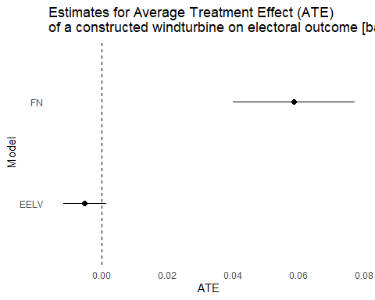

ATE for full model

# Dataframe for plotting  
results <- data.frame(Model = c("FN", "EELV"),  
 ATE = c(ATE.r1,ATE.r3),  
 ATE_se = c(se.r1,se.r3))  
  
ggplot(results, aes(x = ATE, y = Model)) +  
 geom_point(size =2) +  
 geom_errorbarh(aes(xmin = ATE - 1.96 * ATE_se, xmax = ATE + 1.96 * ATE_se), height = 0) +  
 geom_vline(xintercept = 0, linetype = "dashed") +  
 labs(title = "Estimates for Average Treatment Effect (ATE)\nof a constructed windturbine on electoral outcome [full model]",  
 x = "ATE", y = "Model") +  
 theme_minimal()+  
 theme(panel.grid.major = element_blank(),  
 panel.grid.minor = element_blank())

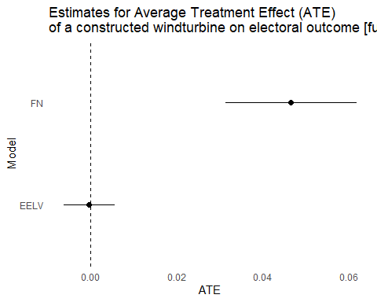

Leads and lags - testing parallel trends assumption for FN

#Leads and lags / Parallel trends assumption   
  
#comparing never treated units, to all units treated by 2022  
ID2022 <- A %>%  
 filter(Y == 2022 & No.Turbines>0) %>%  
 pull(ID) %>%  
 unique()  
  
# treat = departments with wind farm in 2022, regardless of construction year  
A <- A %>%  
 mutate(treat = ifelse(ID %in% ID2022, 1, 0))  
  
#parallel trends, comparing all departments treated by 2022 to never treated departments  
#means, treated  
means.t <- c(  
 mean(A$FN[A$Y==2012&A$treat==1]),  
 mean(A$FN[A$Y==2017&A$treat==1]),  
 mean(A$FN[A$Y==2022&A$treat==1]))  
#means,control  
means.c <- c(  
 mean(A$FN[A$Y==2012&A$treat==0]),  
 mean(A$FN[A$Y==2017&A$treat==0]),  
 mean(A$FN[A$Y==2022&A$treat==0]))  
  
plot(means.t,  
 ylim=c(15,35),  
 type="o",  
 pch=16,  
 col="red",  
 xaxt="n",  
 xlab="Year",  
 ylab="FN Vote (%)")  
lines(means.c,type="o",pch=15,col="black")  
axis(1,at=c(1,2,3),lab=c(2012,2017,2022))  
legend("topright",  
 c("Treated","Control"),  
 col=c("red","black"),  
 pch=c(16,15),  
 lty=c(1,1))

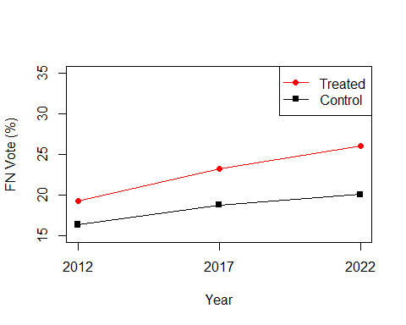

#leads & lags pre-process: 2017 set at treatment time  
temp <- A %>%  
 mutate(treat_t = case_when(treat== 1~2017,treat==0~0)) %>%  
 pre_process_did(yname = "FN", tname = "Y", idname = "ID", gname = "treat_t", allow_unbalanced_panel = TRUE, data =.)  
  
# estimation of ATT  
reg <- temp[['data']]%>%  
 att_gt(yname = "FN", tname = "Y", idname = "ID",gname="treat_t",   
 control_group = c("nevertreated"), est_method = 'dr',   
 allow_unbalanced_panel =TRUE, data=.)

## No pre-treatment periods to test

ggdid(reg)

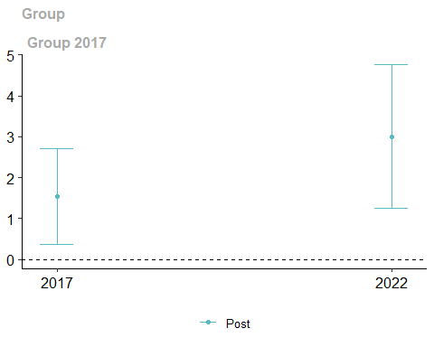

Robustness 1: Extend Analysis to include 2007

Z<-read.csv("Outcome2007-2022.csv") # outcome 2007-2022  
X<-read.csv("Stat-Explanatory2007-2022.csv") # #explanatory 2007-2022  
B<-left_join(Z,X,by=c("ID","Y","Dep")) # complete dataset  
  
ID2022.B <- B %>%  
 filter(Y == 2022 & No.Turbines>0) %>%  
 pull(ID) %>%  
 unique()  
  
# treat = departments with wind-farm in 2022, regardless of construction year  
B <- B %>%  
 mutate(treat = ifelse(ID %in% ID2022.B, 1, 0))  
  
# parallel trends FN  
means.t <- c(mean(B$FN[B$Y==2007&B$treat==1]),  
 mean(B$FN[B$Y==2012&B$treat==1]),  
 mean(B$FN[B$Y==2017&B$treat==1]),  
 mean(B$FN[B$Y==2022&B$treat==1]))  
  
#means,control  
means.c <- c(mean(B$FN[B$Y==2007&B$treat==0]),  
 mean(B$FN[B$Y==2012&B$treat==0]),  
 mean(B$FN[B$Y==2017&B$treat==0]),  
 mean(B$FN[B$Y==2022&B$treat==0]))  
  
plot(means.t,  
 ylim=c(5,35),  
 type="o",  
 pch=16,  
 col="red",  
 xaxt="n",  
 xlab="Year",  
 ylab="FN Vote (%)")  
lines(means.c,type="o",pch=15,col="black")  
axis(1,at=c(1,2,3,4),lab=c(2007,2012,2017,2022))  
legend("topright",  
 c("Treated","Control"),  
 col=c("red","black"),  
 pch=c(16,15),  
 lty=c(1,1))

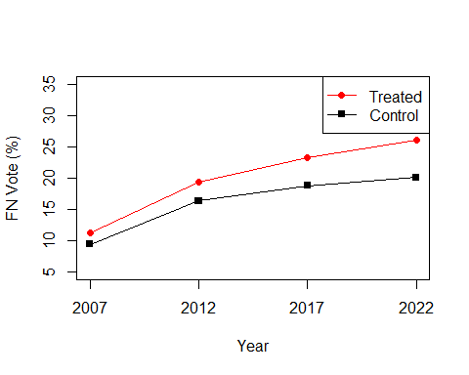

## Parallel trends EELV  
means.t <- c(mean(B$EELV[B$Y==2007&B$treat==1]),  
 mean(B$EELV[B$Y==2012&B$treat==1]),  
 mean(B$EELV[B$Y==2022&B$treat==1]))  
#means,control  
means.c <- c(mean(B$EELV[B$Y==2007&B$treat==0]),  
 mean(B$EELV[B$Y==2012&B$treat==0]),  
 mean(B$EELV[B$Y==2022&B$treat==0]))  
  
plot(means.t,  
 ylim=c(0,10),  
 type="o",  
 pch=16,  
 col="red",  
 xaxt="n",  
 xlab="Year",  
 ylab="EELV Vote (%)")  
lines(means.c,type="o",pch=15,col="black")  
axis(1,at=c(1,2,3),lab=c(2007,2012,2022))  
legend("topright",  
 c("Treated","Control"),  
 col=c("red","black"),  
 pch=c(16,15),  
 lty=c(1,1))

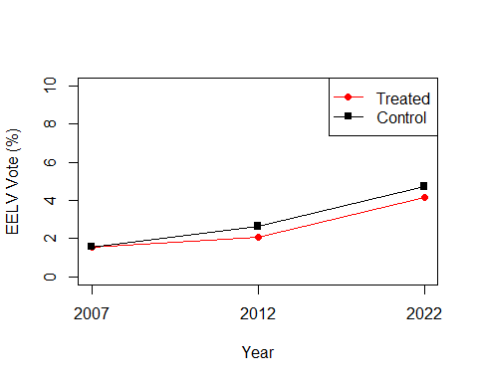

Leads and lags to test parallel trends assumption

#pre-process => 2017 as treatment period   
  
#FN  
temp <- B %>%  
 mutate(treat_t = case_when(treat== 1~2017,treat==0~0)) %>%  
 pre_process_did(yname = "FN", tname = "Y", idname = "ID", gname = "treat_t", allow_unbalanced_panel = TRUE, data =.)  
# B) estimation of ATT  
reg <- temp[['data']]%>%  
 att_gt(yname = "FN", tname = "Y", idname = "ID",gname="treat_t",   
 control_group = c("nevertreated"), est_method = 'dr',   
 allow_unbalanced_panel =TRUE, data=.)  
ggdid(reg)

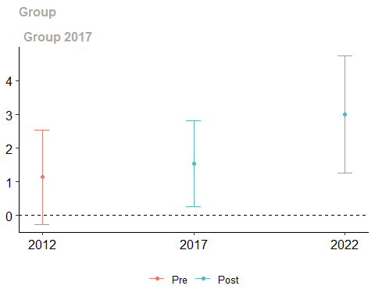

#EELV  
temp2 <- B %>%  
 mutate(treat_t = case_when(treat== 1~2017,treat==0~0)) %>%  
 pre_process_did(yname = "EELV", tname = "Y", idname = "ID", gname = "treat_t", allow_unbalanced_panel = TRUE, data =.)

## Warning in pre_process_did(yname = "EELV", tname = "Y", idname = "ID", gname =  
## "treat_t", : dropped 94 rows from original data due to missing data

# B) estimation of ATT  
reg2 <- temp2[['data']]%>%  
 att_gt(yname = "EELV", tname = "Y", idname = "ID",gname="treat_t",   
 control_group = c("nevertreated"), est_method = 'dr',   
 allow_unbalanced_panel =TRUE, data=.)  
ggdid(reg2)

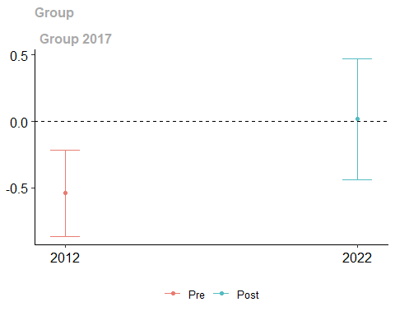

R1: Two-Way Fixed Effects Analysis 2007-2022

##FN  
summary(feols(FN~No.Turbines|Dep+Y, data=B, cluster =~Dep))

## OLS estimation, Dep. Var.: FN  
## Observations: 376  
## Fixed-effects: Dep: 94, Y: 4  
## Standard-errors: Clustered (Dep)   
## Estimate Std. Error t value Pr(>|t|)   
## No.Turbines 0.058454 0.012603 4.63813 1.1469e-05 ***  
## ---  
## Signif. codes: 0 '***' 0.001 '**' 0.01 '*' 0.05 '.' 0.1 ' ' 1  
## RMSE: 1.44575 Adj. R2: 0.947104  
## Within R2: 0.167949

#extract ATE coefficients   
m1<-tidy(lm(FN~No.Turbines+as.factor(Y)+as.factor(Dep), data=B))  
ATE.1 <- m1[m1$term == "No.Turbines", "estimate"]  
se.1 <- m1[m1$term == "No.Turbines", "std.error"]  
ATE.1 <- as.numeric(ATE.1)  
se.1 <- as.numeric(se.1)  
  
##EELV  
summary(feols(EELV~No.Turbines|Dep+Y, data=B, cluster =~Dep))

## NOTE: 94 observations removed because of NA values (LHS: 94).

## OLS estimation, Dep. Var.: EELV  
## Observations: 282  
## Fixed-effects: Dep: 94, Y: 3  
## Standard-errors: Clustered (Dep)   
## Estimate Std. Error t value Pr(>|t|)   
## No.Turbines -0.008091 0.002278 -3.55167 0.0006031 ***  
## ---  
## Signif. codes: 0 '***' 0.001 '**' 0.01 '*' 0.05 '.' 0.1 ' ' 1  
## RMSE: 0.410619 Adj. R2: 0.865239  
## Within R2: 0.056319

#extract ATE coefficients  
m2<-tidy(lm(EELV~No.Turbines+as.factor(Y)+as.factor(Dep), data=B))  
ATE.2 <- m2[m2$term == "No.Turbines", "estimate"]  
se.2 <- m2[m2$term == "No.Turbines", "std.error"]  
ATE.2 <- as.numeric(ATE.2)  
se.2 <- as.numeric(se.2)

Robustness 2: Subset data to only include regions with >1GW generation capacity by 2022

R2 <- read.csv("RobustnessExplanatory .csv") #departments in regions with overall >1GW wind capacity   
  
F_A <- A %>%  
 filter(ID %in% R2$ID)  
length(unique(F_A$ID)) #subset to 63 departments

## [1] 63

#Re-run main analysis   
summary(feols(FN~No.Turbines|Dep+Y, data=F_A, cluster =~Dep)) #0.040

## OLS estimation, Dep. Var.: FN  
## Observations: 189  
## Fixed-effects: Dep: 63, Y: 3  
## Standard-errors: Clustered (Dep)   
## Estimate Std. Error t value Pr(>|t|)   
## No.Turbines 0.039711 0.012243 3.24369 0.0019024 **   
## ---  
## Signif. codes: 0 '***' 0.001 '**' 0.01 '*' 0.05 '.' 0.1 ' ' 1  
## RMSE: 0.940332 Adj. R2: 0.96075   
## Within R2: 0.156251

summary(feols(FN~No.Turbines+Education+Income+log(PopDensity)+Unemployment+ Immigration|Dep+Y,data=F_A, cluster=~Dep)) #0.030

## OLS estimation, Dep. Var.: FN  
## Observations: 189  
## Fixed-effects: Dep: 63, Y: 3  
## Standard-errors: Clustered (Dep)   
## Estimate Std. Error t value Pr(>|t|)   
## No.Turbines 0.029743 0.009665 3.077442 3.1071e-03 **   
## Education -1.085146 0.111568 -9.726301 4.3114e-14 ***  
## Income 0.000068 0.000156 0.435123 6.6498e-01   
## log(PopDensity) 0.414271 0.091646 4.520356 2.8389e-05 ***  
## Unemployment -0.621918 0.199788 -3.112893 2.8020e-03 **   
## Immigration -0.145250 0.100850 -1.440267 1.5482e-01   
## ---  
## Signif. codes: 0 '***' 0.001 '**' 0.01 '*' 0.05 '.' 0.1 ' ' 1  
## RMSE: 0.723087 Adj. R2: 0.975807  
## Within R2: 0.501079

#extract coefficients for ATE figure  
m1 <- tidy(lm(FN~No.Turbines + as.factor(Y)+as.factor(ID), data =F_A))  
ATE.1 <- m1[m1$term == "No.Turbines", "estimate"]  
se.1 <- m1[m1$term == "No.Turbines", "std.error"]  
ATE.1 <- as.numeric(ATE.1)  
se.1 <- as.numeric(se.1)  
  
reg1 <- tidy(lm(FN~No.Turbines +Education+Income+log(PopDensity)+  
Unemployment+ Immigration+ as.factor(Y)+as.factor(ID), data =F_A))  
ATE.r1 <- reg1[reg1$term == "No.Turbines", "estimate"]  
se.r1 <- reg1[reg1$term == "No.Turbines", "std.error"]  
ATE.r1 <- as.numeric(ATE.r1)  
se.r1 <- as.numeric(se.r1)  
  
##EELV 2012-2022: but no observations for 2017  
summary(feols(EELV~No.Turbines|Dep+Y, data=F_A, cluster =~Dep)) #-0.003, not sig

## NOTE: 63 observations removed because of NA values (LHS: 63).

## OLS estimation, Dep. Var.: EELV  
## Observations: 126  
## Fixed-effects: Dep: 63, Y: 2  
## Standard-errors: Clustered (Dep)   
## Estimate Std. Error t value Pr(>|t|)   
## No.Turbines -0.003166 0.002192 -1.44415 0.15373   
## ---  
## Signif. codes: 0 '***' 0.001 '**' 0.01 '*' 0.05 '.' 0.1 ' ' 1  
## RMSE: 0.359441 Adj. R2: 0.843793  
## Within R2: 0.01157

summary(feols(EELV~No.Turbines+Education+Income+log(PopDensity)+ Unemployment+Immigration|Dep+Y,data=F_A, cluster=~Dep)) # 0.004 but significant

## NOTE: 63 observations removed because of NA values (LHS: 63).

## OLS estimation, Dep. Var.: EELV  
## Observations: 126  
## Fixed-effects: Dep: 63, Y: 2  
## Standard-errors: Clustered (Dep)   
## Estimate Std. Error t value Pr(>|t|)   
## No.Turbines 0.003417 0.002727 1.252863 2.1496e-01   
## Education 0.336261 0.056908 5.908904 1.5862e-07 ***  
## Income 0.000192 0.000065 2.937713 4.6370e-03 **   
## log(PopDensity) -0.015171 0.044594 -0.340204 7.3485e-01   
## Unemployment -0.385244 0.105847 -3.639640 5.5806e-04 ***  
## Immigration 0.200666 0.055165 3.637565 5.6178e-04 ***  
## ---  
## Signif. codes: 0 '***' 0.001 '**' 0.01 '*' 0.05 '.' 0.1 ' ' 1  
## RMSE: 0.242001 Adj. R2: 0.922871  
## Within R2: 0.551953

#extract coefficients for ATE figure  
m3 <- tidy(lm(EELV~No.Turbines +as.factor(Y)+as.factor(ID), data =F_A))  
ATE.3 <- m3[m3$term == "No.Turbines", "estimate"]  
se.3 <- m3[m3$term == "No.Turbines", "std.error"]  
ATE.3 <- as.numeric(ATE.3)  
se.3 <- as.numeric(se.3)  
  
reg3<-tidy(lm(EELV~No.Turbines+Education+Income+log(PopDensity)+  
 Unemployment+Immigration+as.factor(Y)+as.factor(ID), data=F_A))  
ATE.r3 <- reg3[reg3$term == "No.Turbines", "estimate"]  
se.r3 <- reg3[reg3$term == "No.Turbines", "std.error"]  
ATE.r3 <- as.numeric(ATE.r3)  
se.r3 <- as.numeric(se.r3)

R2: ATE Baseline and Full Model

##Baseline  
#Dataframe for plotting  
results <- data.frame(Model = c("FN","EELV"),  
 ATE = c(ATE.1, ATE.3),  
 ATE_se = c(se.1,se.3 ))  
  
ggplot(results, aes(x = ATE, y = Model)) +  
 geom_point(size =2) +  
 geom_errorbarh(aes(xmin = ATE - 1.96 * ATE_se, xmax = ATE + 1.96 * ATE_se), height = 0) +  
 geom_vline(xintercept = 0, linetype = "dashed") +  
 labs(title = "Estimates for Average Treatment Effect (ATE)\nof a constructed windturbine on electoral outcome [baseline model]",  
 x = "ATE", y = "Model") +  
 theme_minimal()+  
 theme(panel.grid.major = element_blank(),  
 panel.grid.minor = element_blank())

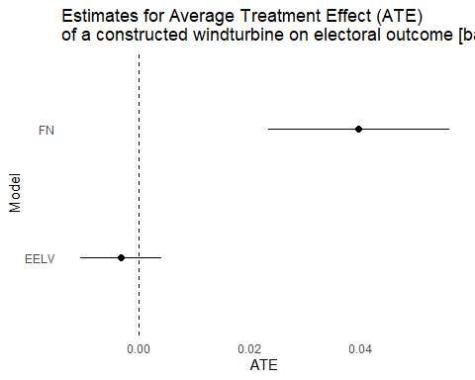

##Full Model  
# Dataframe for plotting  
results <- data.frame(Model = c("FN", "EELV"),  
 ATE = c(ATE.r1,ATE.r3),  
 ATE_se = c(se.r1,se.r3))  
  
ggplot(results, aes(x = ATE, y = Model)) +  
 geom_point(size =2) +  
 geom_errorbarh(aes(xmin = ATE - 1.96 * ATE_se, xmax = ATE + 1.96 * ATE_se), height = 0) +  
 geom_vline(xintercept = 0, linetype = "dashed") +  
 labs(title = "Estimates for Average Treatment Effect (ATE)\nof a constructed windturbine on electoral outcome [full model]",  
 x = "ATE", y = "Model") +  
 theme_minimal()+  
 theme(panel.grid.major = element_blank(),  
 panel.grid.minor = element_blank())

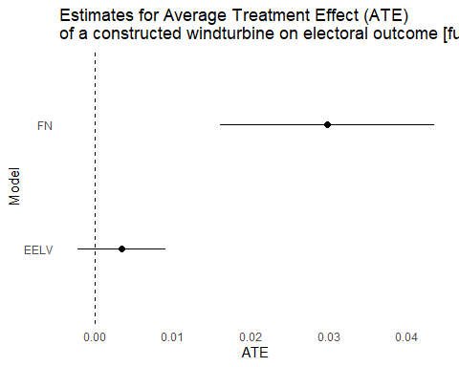

Robustness 3: Analysis for LR and PS 2012-2022

#2012-2022: full model   
  
#PS  
summary(feols(PS~No.Turbines+ Education+ Income+ log(PopDensity)+ Unemployment+ Immigration|Dep+Y, data=A, cluster =~Dep))

## OLS estimation, Dep. Var.: PS  
## Observations: 282  
## Fixed-effects: Dep: 94, Y: 3  
## Standard-errors: Clustered (Dep)   
## Estimate Std. Error t value Pr(>|t|)   
## No.Turbines -0.007692 0.012309 -0.624889 5.3357e-01   
## Education -0.496446 0.143194 -3.466955 7.9877e-04 ***  
## Income -0.000828 0.000414 -2.000060 4.8411e-02 *   
## log(PopDensity) -0.844283 0.129037 -6.542965 3.2424e-09 ***  
## Unemployment 0.074891 0.400447 0.187018 8.5205e-01   
## Immigration 0.000616 0.170772 0.003606 9.9713e-01   
## ---  
## Signif. codes: 0 '***' 0.001 '**' 0.01 '*' 0.05 '.' 0.1 ' ' 1  
## RMSE: 1.69322 Adj. R2: 0.967826  
## Within R2: 0.095488

#extract ATE coefficient  
m3<-tidy(lm(PS~No.Turbines+as.factor(Y)+as.factor(Dep), data=A))  
ATE.3 <- m3[m3$term == "No.Turbines", "estimate"]  
se.3 <- m3[m3$term == "No.Turbines", "std.error"]  
ATE.3 <- as.numeric(ATE.3)  
se.3 <- as.numeric(se.3)  
  
#LR  
summary(feols(LR~No.Turbines+ Education+ Income+ log(PopDensity)+ Unemployment+ Immigration|ID+Y,data=A, cluster=~ID))

## OLS estimation, Dep. Var.: LR  
## Observations: 282  
## Fixed-effects: ID: 94, Y: 3  
## Standard-errors: Clustered (ID)   
## Estimate Std. Error t value Pr(>|t|)   
## No.Turbines 0.005312 0.010007 0.530831 0.5968013   
## Education -0.066516 0.153217 -0.434128 0.6652010   
## Income 0.000035 0.000154 0.229297 0.8191416   
## log(PopDensity) 0.219825 0.465330 0.472406 0.6377437   
## Unemployment 0.854512 0.280245 3.049156 0.0029888 **   
## Immigration 0.131764 0.070651 1.864987 0.0653366 .   
## ---  
## Signif. codes: 0 '***' 0.001 '**' 0.01 '*' 0.05 '.' 0.1 ' ' 1  
## RMSE: 1.2874 Adj. R2: 0.957225  
## Within R2: 0.075326

#extract ATE coefficient   
m4<-tidy(lm(LR~No.Turbines+as.factor(Y)+as.factor(Dep),data=A))  
ATE.4 <- m4[m4$term == "No.Turbines", "estimate"]  
se.4 <- m4[m4$term == "No.Turbines", "std.error"]  
ATE.4 <- as.numeric(ATE.4)  
se.4 <- as.numeric(se.4)  
  
  
# Create a dataframe for plotting  
results <- data.frame(Model = c( "PS","LR"),  
 ATE = c(ATE.3,ATE.4),  
 ATE_se = c(se.3,se.4))  
  
ggplot(results, aes(x = ATE, y = Model)) +  
 geom_point(size =2) +  
 geom_errorbarh(aes(xmin = ATE - 1.96 * ATE_se, xmax = ATE + 1.96 * ATE_se), height = 0) +  
 geom_vline(xintercept = 0, linetype = "dashed") +  
 labs(title = "Estimates for Average Treatment Effect (ATE)\nof a constructed windturbine on electoral outcome [full model]",  
 x = "ATE", y = "Model") +  
 theme_minimal()+  
 theme(panel.grid.major = element_blank(),  
 panel.grid.minor = element_blank())

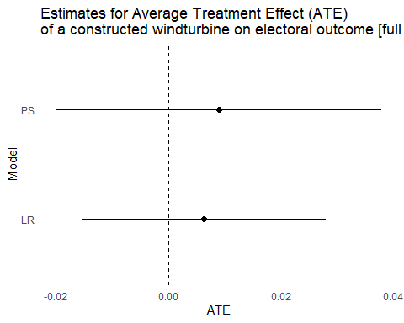 Parallel trends

##PS  
means.t <- c(  
 mean(A$PS[A$Y==2012&A$treat==1]),  
 mean(A$PS[A$Y==2017&A$treat==1]),  
 mean(A$PS[A$Y==2022&A$treat==1]))  
#means,control  
means.c <- c(  
 mean(A$PS[A$Y==2012&A$treat==0]),  
 mean(A$PS[A$Y==2017&A$treat==0]),  
 mean(A$PS[A$Y==2022&A$treat==0]))  
  
plot(means.t,  
 ylim=c(0,30),  
 type="o",  
 pch=16,  
 col="red",  
 xaxt="n",  
 xlab="Year",  
 ylab="PS Vote (%)")  
lines(means.c,type="o",pch=15,col="black")  
axis(1,at=c(1,2,3),lab=c(2012,2017,2022))  
legend("topright",  
 c("Treated","Control"),  
 col=c("red","black"),  
 pch=c(16,15),  
 lty=c(1,1))

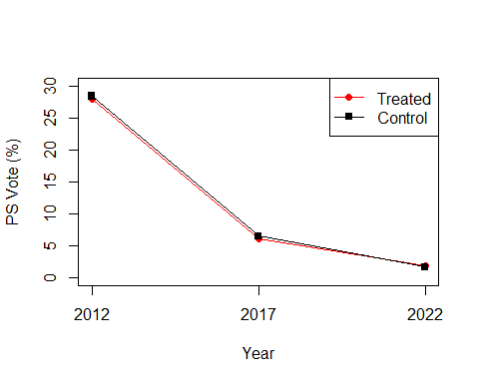

##LR  
means.t <- c(  
 mean(A$LR[A$Y==2012&A$treat==1]),  
 mean(A$LR[A$Y==2017&A$treat==1]),  
 mean(A$LR[A$Y==2022&A$treat==1]))  
#means,control  
means.c <- c(  
 mean(A$LR[A$Y==2012&A$treat==0]),  
 mean(A$LR[A$Y==2017&A$treat==0]),  
 mean(A$LR[A$Y==2022&A$treat==0]))  
  
plot(means.t,  
 ylim=c(0,35),  
 type="o",  
 pch=16,  
 col="red",  
 xaxt="n",  
 xlab="Year",  
 ylab="LR Vote (%)")  
lines(means.c,type="o",pch=15,col="black")  
axis(1,at=c(1,2,3),lab=c(2012,2017,2022))  
legend("topright",  
 c("Treated","Control"),  
 col=c("red","black"),  
 pch=c(16,15),  
 lty=c(1,1))

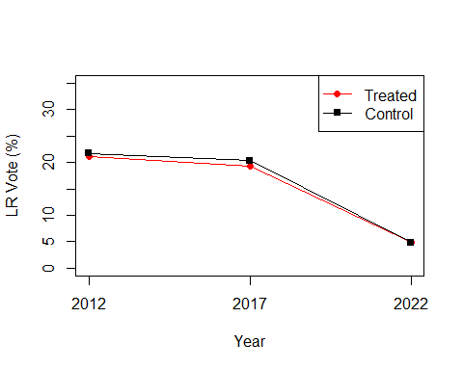

Robustness 4: Wind Market data 2012-2022, includes data on both operational and commissioned wind turbines

##re-run analysis with second dataset   
s<-read.csv("V1-Explanatory2012-2022.csv") # Explanatory variable for 2012-2022 periods   
R<-left_join(Z,s,by=c("ID","Y","Dep"))  
R <- R[!(R$Y==2007),]#remove 2007 from dataset  
R<-left_join(R,combined,by=c("ID","Y"))  
R<-left_join(R,e,by=c("ID","Y","Dep"))  
R <- R %>%  
mutate(PopDensity = ifelse(Y == 2012 & is.na(PopDensity), (Population/Area), PopDensity))  
  
  
##FN - Turbines - 2012-2022  
summary(feols(FN~No.Turbines|Dep+Y, data=R, cluster =~Dep))# 0.014

## OLS estimation, Dep. Var.: FN  
## Observations: 282  
## Fixed-effects: Dep: 94, Y: 3  
## Standard-errors: Clustered (Dep)   
## Estimate Std. Error t value Pr(>|t|)   
## No.Turbines 0.013939 0.003603 3.86922 0.00020249 ***  
## ---  
## Signif. codes: 0 '***' 0.001 '**' 0.01 '*' 0.05 '.' 0.1 ' ' 1  
## RMSE: 1.14592 Adj. R2: 0.945434  
## Within R2: 0.164881

summary(feols(FN~No.Turbines+ Education+ Income+ log(PopDensity)+ Unemployment+ Immigration|Dep+Y, data=R, cluster =~Dep)) # 0.011

## OLS estimation, Dep. Var.: FN  
## Observations: 282  
## Fixed-effects: Dep: 94, Y: 3  
## Standard-errors: Clustered (Dep)   
## Estimate Std. Error t value Pr(>|t|)   
## No.Turbines 0.011032 0.003206 3.441447 0.00086854 ***  
## Education -0.826049 0.272947 -3.026405 0.00320098 **   
## Income 0.000323 0.000120 2.691011 0.00844646 **   
## log(PopDensity) 0.278744 0.207495 1.343379 0.18241811   
## Unemployment -0.678958 0.207233 -3.276303 0.00147899 **   
## Immigration 0.051810 0.099339 0.521551 0.60322282   
## ---  
## Signif. codes: 0 '***' 0.001 '**' 0.01 '*' 0.05 '.' 0.1 ' ' 1  
## RMSE: 0.892812 Adj. R2: 0.965956  
## Within R2: 0.493053

##EELV  
summary(feols(EELV~No.Turbines|Dep+Y, data=R, cluster =~Dep)) # -0.001

## NOTE: 94 observations removed because of NA values (LHS: 94).

## OLS estimation, Dep. Var.: EELV  
## Observations: 188  
## Fixed-effects: Dep: 94, Y: 2  
## Standard-errors: Clustered (Dep)   
## Estimate Std. Error t value Pr(>|t|)   
## No.Turbines -0.001135 0.000522 -2.17186 0.03241 *   
## ---  
## Signif. codes: 0 '***' 0.001 '**' 0.01 '*' 0.05 '.' 0.1 ' ' 1  
## RMSE: 0.347136 Adj. R2: 0.870849  
## Within R2: 0.020383

summary(feols(EELV~No.Turbines+ Education+ Income+ log(PopDensity)+ Unemployment+ Immigration|Dep+Y,data=R, cluster=~Dep)) # insignificant

## NOTE: 94 observations removed because of NA values (LHS: 94).

## OLS estimation, Dep. Var.: EELV  
## Observations: 188  
## Fixed-effects: Dep: 94, Y: 2  
## Standard-errors: Clustered (Dep)   
## Estimate Std. Error t value Pr(>|t|)   
## No.Turbines -0.000059 0.000732 -0.080174 0.9362708   
## Education 0.213381 0.083094 2.567961 0.0118234 *   
## Income 0.000120 0.000058 2.063958 0.0418073 *   
## log(PopDensity) 0.071704 0.191387 0.374652 0.7087720   
## Unemployment -0.260484 0.098493 -2.644685 0.0095987 **   
## Immigration 0.066174 0.042752 1.547855 0.1250535   
## ---  
## Signif. codes: 0 '***' 0.001 '**' 0.01 '*' 0.05 '.' 0.1 ' ' 1  
## RMSE: 0.28689 Adj. R2: 0.906718  
## Within R2: 0.330905

Testing the Mechanism: TWFE turnout~wind.turbines

t<-read.csv("Turnout2012-2022.csv") #turnout data  
T<-left_join(A,t, by=c("ID","Y","Dep")) #combine with original dataset   
  
mean(T$MetFrance)

## [1] 79.70227

mean(T$FN.y)

## [1] 17.1323

mean(T$EELV.y, na.rm=TRUE)

## [1] 2.476755

#baseline model   
#Metropolitan France   
summary(feols(MetFrance~No.Turbines|Y+Dep, data=T,cluster=~Dep))

## OLS estimation, Dep. Var.: MetFrance  
## Observations: 282  
## Fixed-effects: Y: 3, Dep: 94  
## Standard-errors: Clustered (Dep)   
## Estimate Std. Error t value Pr(>|t|)   
## No.Turbines -0.018715 0.00505 -3.70586 0.00035765 ***  
## ---  
## Signif. codes: 0 '***' 0.001 '**' 0.01 '*' 0.05 '.' 0.1 ' ' 1  
## RMSE: 0.839768 Adj. R2: 0.892029  
## Within R2: 0.037763

m1<-tidy(lm(MetFrance~No.Turbines+as.factor(Y)+as.factor(Dep), data=T))  
ATE.1<- m1[m1$term == "No.Turbines", "estimate"]  
se.1<- m1[m1$term == "No.Turbines", "std.error"]  
ATE.1<- as.numeric(ATE.1)  
se.1<- as.numeric(se.1)  
  
#FN  
summary(feols(FN.y~No.Turbines|Y+Dep, data=T,cluster=~Dep))

## OLS estimation, Dep. Var.: FN.y  
## Observations: 282  
## Fixed-effects: Y: 3, Dep: 94  
## Standard-errors: Clustered (Dep)   
## Estimate Std. Error t value Pr(>|t|)   
## No.Turbines 0.032572 0.009593 3.39547 0.001009 **   
## ---  
## Signif. codes: 0 '***' 0.001 '**' 0.01 '*' 0.05 '.' 0.1 ' ' 1  
## RMSE: 0.846561 Adj. R2: 0.941982  
## Within R2: 0.104726

m2<-tidy(lm(FN.y~No.Turbines+as.factor(Y)+as.factor(Dep), data=T))  
ATE.2<- m2[m2$term == "No.Turbines", "estimate"]  
se.2<- m2[m2$term == "No.Turbines", "std.error"]  
ATE.2<- as.numeric(ATE.2)  
se.2<- as.numeric(se.2)  
  
#EELV  
summary(feols(EELV.y~No.Turbines|Y+Dep, data=T,cluster=~Dep))

## NOTE: 94 observations removed because of NA values (LHS: 94).

## OLS estimation, Dep. Var.: EELV.y  
## Observations: 188  
## Fixed-effects: Y: 2, Dep: 94  
## Standard-errors: Clustered (Dep)   
## Estimate Std. Error t value Pr(>|t|)   
## No.Turbines -0.004197 0.001491 -2.81513 0.0059519 **   
## ---  
## Signif. codes: 0 '***' 0.001 '**' 0.01 '*' 0.05 '.' 0.1 ' ' 1  
## RMSE: 0.264315 Adj. R2: 0.863298  
## Within R2: 0.028175

m4<-tidy(lm(EELV.y~No.Turbines+as.factor(Y)+as.factor(Dep), data=T))  
ATE.4<- m4[m4$term == "No.Turbines", "estimate"]  
se.4<- m4[m4$term == "No.Turbines", "std.error"]  
ATE.4<- as.numeric(ATE.4)  
se.4<- as.numeric(se.4)  
  
#dataframe for plotting  
results <- data.frame(Model = c("Overall:Met France", "FN", "EELV"),  
ATE = c(ATE.1, ATE.2,ATE.4),  
ATE_se = c(se.1, se.2,se.4))  
  
ggplot(results, aes(x = ATE, y = Model)) +  
 geom_point(size =2) +  
 geom_errorbarh(aes(xmin = ATE - 1.96 * ATE_se, xmax = ATE + 1.96 * ATE_se), height = 0) +  
 geom_vline(xintercept = 0, linetype = "dashed") +  
 labs(title = "Estimates for Average Treatment Effect (ATE) of a\nconstructed wind turbine on voter turnout [baseline model]",  
 x = "ATE", y = "Model") +  
 theme_minimal()+  
 theme(panel.grid.major = element_blank(),  
 panel.grid.minor = element_blank())

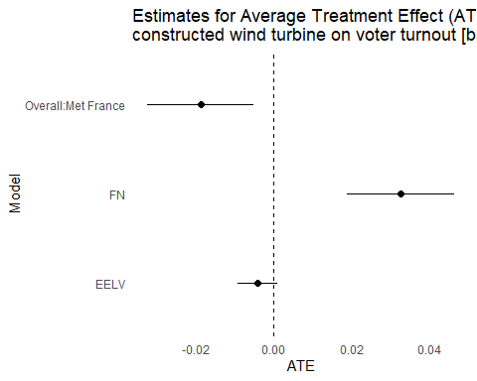

#full model  
#Metropolitan France   
summary(feols(MetFrance~No.Turbines+Education+Income+log(PopDensity)+Unemployment+Immigration|Y+Dep, data=T,cluster=~Dep))

## OLS estimation, Dep. Var.: MetFrance  
## Observations: 282  
## Fixed-effects: Y: 3, Dep: 94  
## Standard-errors: Clustered (Dep)   
## Estimate Std. Error t value Pr(>|t|)   
## No.Turbines -0.015295 0.004985 -3.068159 0.00282162 **   
## Education 0.391537 0.136041 2.878081 0.00496332 **   
## Income -0.000412 0.000113 -3.637268 0.00045203 ***  
## log(PopDensity) -0.245516 0.333333 -0.736547 0.46325205   
## Unemployment 0.052548 0.117070 0.448863 0.65457497   
## Immigration -0.007860 0.045042 -0.174499 0.86185286   
## ---  
## Signif. codes: 0 '***' 0.001 '**' 0.01 '*' 0.05 '.' 0.1 ' ' 1  
## RMSE: 0.74114 Adj. R2: 0.913565  
## Within R2: 0.250514

m1<-tidy(lm(MetFrance~No.Turbines+ Education+ Income+ log(PopDensity)+ Unemployment+ Immigration+ as.factor(Y)+as.factor(Dep), data=T))   
ATE.1<- m1[m1$term == "No.Turbines", "estimate"]  
se.1<- m1[m1$term == "No.Turbines", "std.error"]  
ATE.1<- as.numeric(ATE.1)  
se.1<- as.numeric(se.1)  
  
#FN  
summary(feols(FN.y~No.Turbines+ Education+ Income+ log(PopDensity)+ Unemployment+ Immigration|Y+Dep, data=T,cluster=~Dep))

## OLS estimation, Dep. Var.: FN.y  
## Observations: 282  
## Fixed-effects: Y: 3, Dep: 94  
## Standard-errors: Clustered (Dep)   
## Estimate Std. Error t value Pr(>|t|)   
## No.Turbines 0.025553 0.008782 2.909635 0.0045268 **   
## Education -0.497105 0.170211 -2.920527 0.0043845 **   
## Income 0.000249 0.000087 2.861273 0.0052113 **   
## log(PopDensity) 0.015452 0.310163 0.049818 0.9603744   
## Unemployment -0.510680 0.165954 -3.077246 0.0027448 **   
## Immigration 0.042953 0.064016 0.670980 0.5038961   
## ---  
## Signif. codes: 0 '***' 0.001 '**' 0.01 '*' 0.05 '.' 0.1 ' ' 1  
## RMSE: 0.715043 Adj. R2: 0.957459  
## Within R2: 0.361291

m2<-tidy(lm(FN.y~No.Turbines+ Education+ Income+ log(PopDensity)+  
Unemployment+Immigration+ as.factor(Y)+as.factor(Dep), data=T))  
ATE.2<- m2[m2$term == "No.Turbines", "estimate"]  
se.2<- m2[m2$term == "No.Turbines", "std.error"]  
ATE.2<- as.numeric(ATE.2)  
se.2<- as.numeric(se.2)  
  
#EELV  
summary(feols(EELV.y~No.Turbines+Education+ Income+ log(PopDensity)+ Unemployment+ Immigration |Y+Dep, data=T,cluster=~Dep))

## NOTE: 94 observations removed because of NA values (LHS: 94).

## OLS estimation, Dep. Var.: EELV.y  
## Observations: 188  
## Fixed-effects: Y: 2, Dep: 94  
## Standard-errors: Clustered (Dep)   
## Estimate Std. Error t value Pr(>|t|)   
## No.Turbines -0.000364 0.002351 -0.154850 0.877275   
## Education 0.168443 0.065625 2.566751 0.011862 *   
## Income 0.000099 0.000045 2.181085 0.031699 *   
## log(PopDensity) 0.042250 0.134686 0.313693 0.754457   
## Unemployment -0.193338 0.076284 -2.534443 0.012934 *   
## Immigration 0.046785 0.032330 1.447088 0.151235   
## ---  
## Signif. codes: 0 '***' 0.001 '**' 0.01 '*' 0.05 '.' 0.1 ' ' 1  
## RMSE: 0.216345 Adj. R2: 0.903152  
## Within R2: 0.348914

m4<-tidy(lm(EELV.y~No.Turbines+ Education+ Income+ log(PopDensity)+  
Unemployment+Immigration+as.factor(Y)+as.factor(Dep), data=T))  
ATE.4<- m4[m4$term == "No.Turbines", "estimate"]  
se.4<- m4[m4$term == "No.Turbines", "std.error"]  
ATE.4<- as.numeric(ATE.4)  
se.4<- as.numeric(se.4)  
  
results <- data.frame(Model = c("Overall:Met France", "FN", "EELV"),  
 ATE = c(ATE.1, ATE.2,ATE.4),  
 ATE_se = c(se.1, se.2,se.4))  
  
ggplot(results, aes(x = ATE, y = Model)) +  
 geom_point(size =2) +  
 geom_errorbarh(aes(xmin = ATE - 1.96 * ATE_se, xmax = ATE + 1.96 * ATE_se), height = 0) +  
 geom_vline(xintercept = 0, linetype = "dashed") +  
 labs(title = "Estimates for Average Treatment Effect (ATE) of a\nconstructed wind turbine on voter turnout [full model]",  
 x = "ATE", y = "Model") +  
 theme_minimal()+  
 theme(panel.grid.major = element_blank(),  
 panel.grid.minor = element_blank())

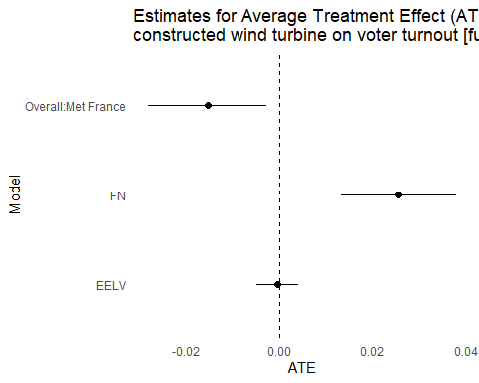 Linear Regression Assumptions

##FN   
#Subset 2022 and 2017  
df22<- A[A$Y %in% 2022,]  
df22<- subset(df22, select = c(FN, No.Turbines, Education, Unemployment, Income, Immigration, PopDensity))  
df17<- A[A$Y %in% 2017,]  
df17<- subset(df17, select = c(FN, No.Turbines, Education, Unemployment, Income, Immigration, PopDensity))  
  
## Linearity ##  
cor(df22)

## FN No.Turbines Education Unemployment Income  
## FN 1.0000000 0.4561019 -0.7365313 0.40372023 -0.5792178  
## No.Turbines 0.4561019 1.0000000 -0.2610045 0.25100667 -0.2497733  
## Education -0.7365313 -0.2610045 1.0000000 -0.12227756 0.7991634  
## Unemployment 0.4037202 0.2510067 -0.1222776 1.00000000 -0.4503136  
## Income -0.5792178 -0.2497733 0.7991634 -0.45031358 1.0000000  
## Immigration -0.4218038 -0.3373116 0.4984349 0.25296970 0.3029699  
## PopDensity -0.5417556 -0.1387602 0.7506039 -0.04613457 0.5045802  
## Immigration PopDensity  
## FN -0.4218038 -0.54175561  
## No.Turbines -0.3373116 -0.13876023  
## Education 0.4984349 0.75060386  
## Unemployment 0.2529697 -0.04613457  
## Income 0.3029699 0.50458017  
## Immigration 1.0000000 0.33403274  
## PopDensity 0.3340327 1.00000000

rcorr(as.matrix(df22))

## FN No.Turbines Education Unemployment Income Immigration  
## FN 1.00 0.46 -0.74 0.40 -0.58 -0.42  
## No.Turbines 0.46 1.00 -0.26 0.25 -0.25 -0.34  
## Education -0.74 -0.26 1.00 -0.12 0.80 0.50  
## Unemployment 0.40 0.25 -0.12 1.00 -0.45 0.25  
## Income -0.58 -0.25 0.80 -0.45 1.00 0.30  
## Immigration -0.42 -0.34 0.50 0.25 0.30 1.00  
## PopDensity -0.54 -0.14 0.75 -0.05 0.50 0.33  
## PopDensity  
## FN -0.54  
## No.Turbines -0.14  
## Education 0.75  
## Unemployment -0.05  
## Income 0.50  
## Immigration 0.33  
## PopDensity 1.00  
##   
## n= 94   
##   
##   
## P  
## FN No.Turbines Education Unemployment Income Immigration  
## FN 0.0000 0.0000 0.0000 0.0000 0.0000   
## No.Turbines 0.0000 0.0111 0.0147 0.0152 0.0009   
## Education 0.0000 0.0111 0.2404 0.0000 0.0000   
## Unemployment 0.0000 0.0147 0.2404 0.0000 0.0139   
## Income 0.0000 0.0152 0.0000 0.0000 0.0030   
## Immigration 0.0000 0.0009 0.0000 0.0139 0.0030   
## PopDensity 0.0000 0.1823 0.0000 0.6588 0.0000 0.0010   
## PopDensity  
## FN 0.0000   
## No.Turbines 0.1823   
## Education 0.0000   
## Unemployment 0.6588   
## Income 0.0000   
## Immigration 0.0010   
## PopDensity

ggpairs(df22, axisLabels="internal")

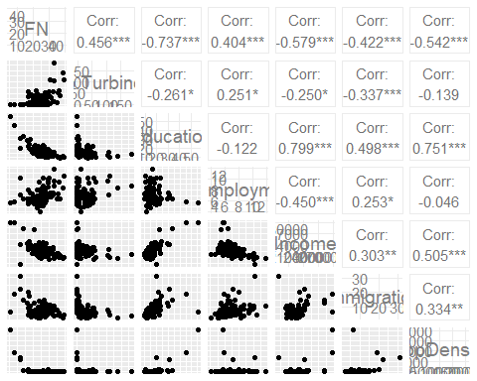

ggpairs(df17, axisLabels="internal")

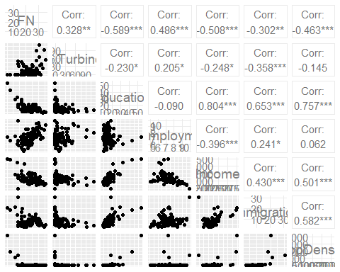

par(mfrow=c(2,3))  
plot(df22$FN, log(df22$No.Turbines))  
plot(df22$FN, df22$No.Turbines)  
plot(df22$FN, df22$Education)  
plot(df22$FN, df22$Unemployment)  
plot(df22$FN, log(df22$PopDensity))  
plot(df22$FN, df22$Income)

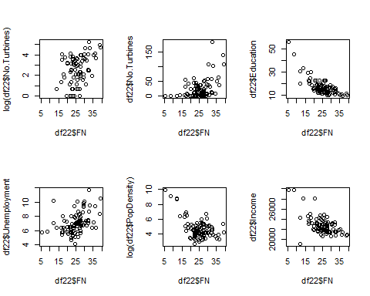

plot(df22$FN, df22$Immigration)  
  
plot(df17$FN, log(df17$No.Turbines))  
plot(df17$FN, df17$Education)  
plot(df17$FN, df17$Unemployment)  
plot(df17$FN, log(df17$PopDensity))  
plot(df17$FN, df17$Income)

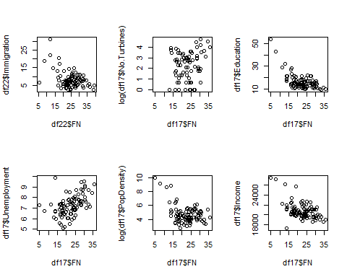

plot(df17$FN, df17$Immigration)  
par(mfrow=c(1,1))

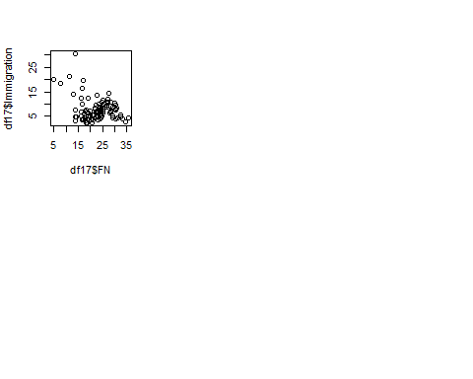

##Residuals ##   
##2022  
m1<-lm(FN~No.Turbines+ Education + Income+ log(PopDensity)+ Unemployment+ Immigration, data=df17)  
residualPlots(m1) # turkey test not signficiant at 5% level

## Test stat Pr(>|Test stat|)   
## No.Turbines 1.1620 0.2484   
## Education 0.4571 0.6488   
## Income -0.8960 0.3728   
## log(PopDensity) -1.5407 0.1271   
## Unemployment -0.2662 0.7907   
## Immigration -5.0382 2.567e-06 ***  
## Tukey test 0.7260 0.4678   
## ---  
## Signif. codes: 0 '***' 0.001 '**' 0.01 '*' 0.05 '.' 0.1 ' ' 1

ncvTest(m1) # test insignificant, there is not a probelm with non constant variance

## Non-constant Variance Score Test   
## Variance formula: ~ fitted.values   
## Chisquare = 0.3969248, Df = 1, p = 0.52868

##2017  
m2<-lm(FN~No.Turbines+ Education + Income+  
 log(PopDensity)+ Unemployment+ Immigration, data=df17)  
residualPlots(m2) # turkey test is not significant

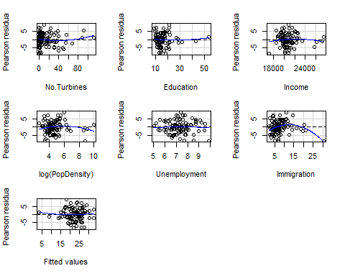

## Test stat Pr(>|Test stat|)   
## No.Turbines 1.1620 0.2484   
## Education 0.4571 0.6488   
## Income -0.8960 0.3728   
## log(PopDensity) -1.5407 0.1271   
## Unemployment -0.2662 0.7907   
## Immigration -5.0382 2.567e-06 ***  
## Tukey test 0.7260 0.4678   
## ---  
## Signif. codes: 0 '***' 0.001 '**' 0.01 '*' 0.05 '.' 0.1 ' ' 1

ncvTest(m2) # not significant

## Non-constant Variance Score Test   
## Variance formula: ~ fitted.values   
## Chisquare = 0.3969248, Df = 1, p = 0.52868

##Normality, outliers and influencial data   
##2022  
plot(density(rstudent(m1))) ## roughly approximates a normal distribution

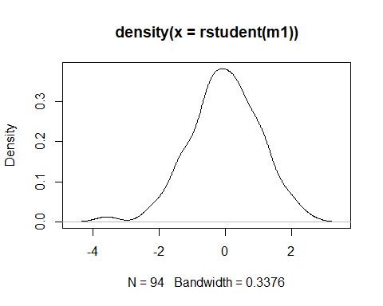

qqPlot(m1) # 2 outliers

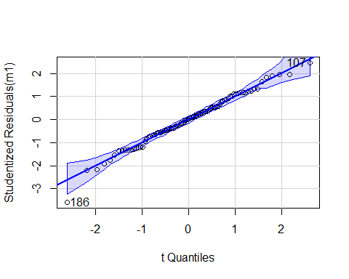

## 107 186   
## 13 92

outlierTest(m1) # unadjusted p-value, less than p<0.05, and bonferroni p large, so no evidence of outliers

## No Studentized residuals with Bonferroni p < 0.05  
## Largest |rstudent|:  
## rstudent unadjusted p-value Bonferroni p  
## 186 -3.579562 0.00056873 0.053461

#2017   
plot(density(rstudent(m2))) ## left hand side tail slightly longer than it should be

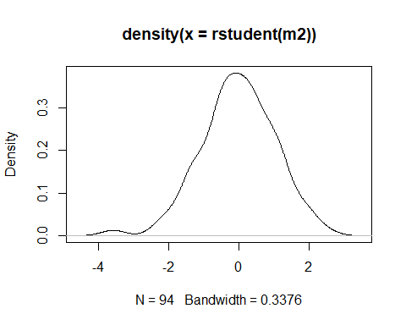

qqPlot(m2) # 2 outliers

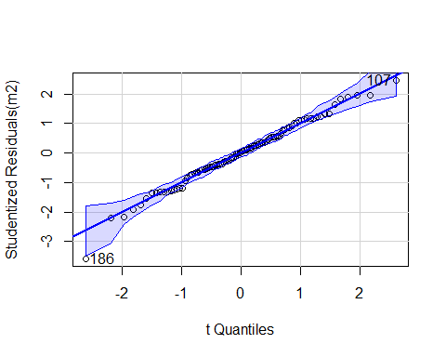

## 107 186   
## 13 92

outlierTest(m2) # unadjusted p-value, less than p<0.05, and bonferroni p larger than 0.05

## No Studentized residuals with Bonferroni p < 0.05  
## Largest |rstudent|:  
## rstudent unadjusted p-value Bonferroni p  
## 186 -3.579562 0.00056873 0.053461

##EELV   
df22<- A[A$Y %in% 2022,]  
df22<- subset(df22, select = c(EELV, No.Turbines, Education, Unemployment, Income, Immigration, PopDensity))  
  
df12<- A[A$Y %in% 2012,]  
df12<- subset(df12, select = c(EELV, No.Turbines, Education, Unemployment, Income, Immigration, PopDensity))  
  
## Linearity ##  
ggpairs(df22, axisLabels="internal")

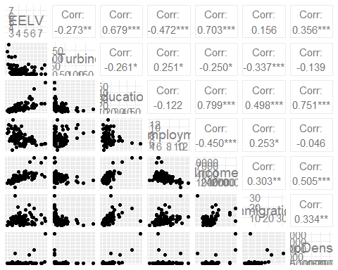

ggpairs(df12, axisLabels="internal")

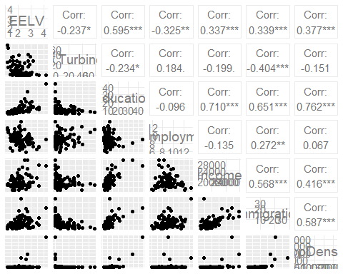

plot(df22$EELV, log(df22$No.Turbines))

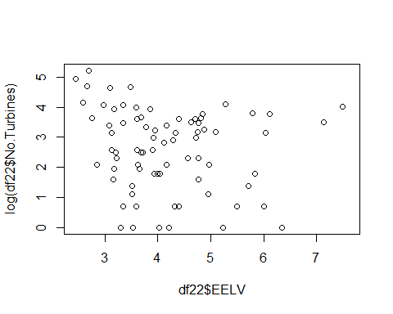

plot(df22$EELV, df22$Education)

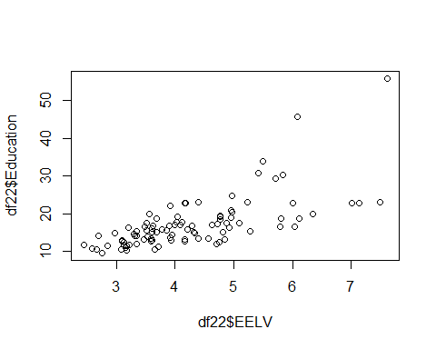

plot(df22$EELV, df22$Unemployment)

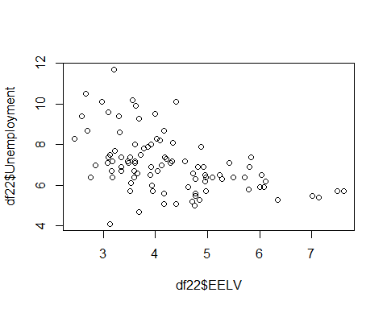

plot(df22$EELV, log(df22$PopDensity))

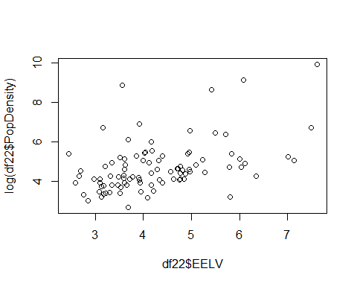

plot(df22$EELV, df22$Income)

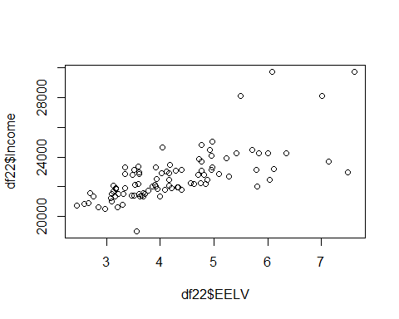

plot(df22$EELV, df22$Immigration)

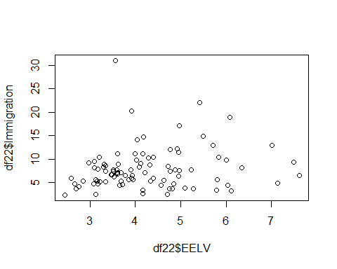

plot(df12$EELV, log(df12$No.Turbines))

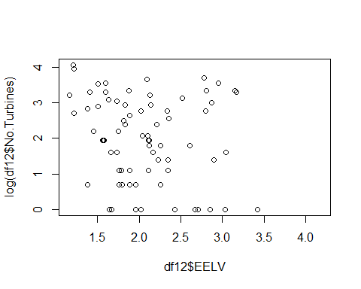

plot(df12$EELV, df12$Education)

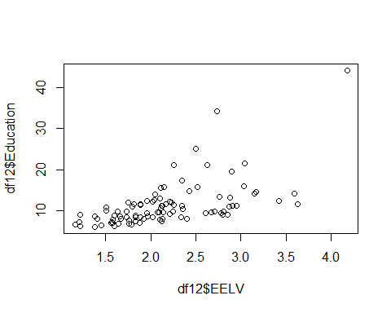

plot(df12$EELV, df12$Unemployment)

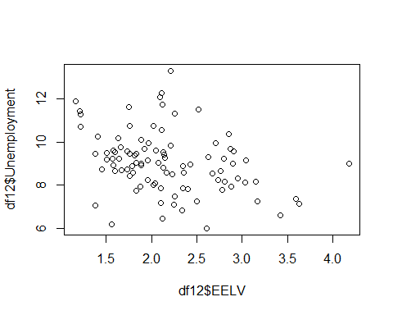

plot(df12$EELV, log(df12$PopDensity))

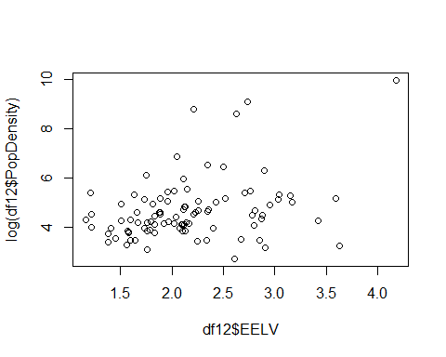

plot(df12$EELV, df12$Income)

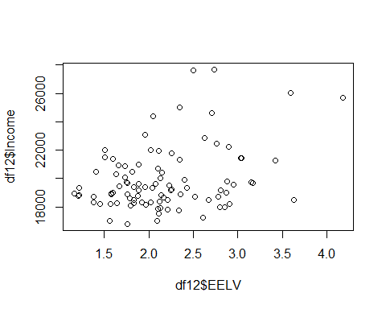

plot(df12$EELV, df12$Immigration)

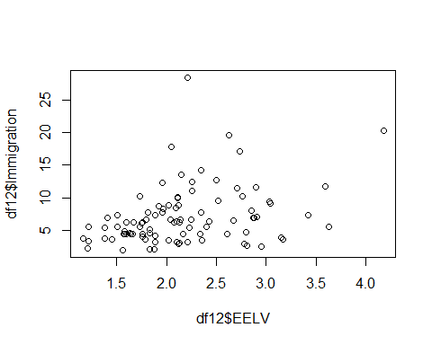

##2022  
m1<-lm(EELV~No.Turbines+ Education + Income+log(PopDensity)+ Unemployment+ Immigration, data=df22)  
residualPlots(m1) # turkey test significant, problem

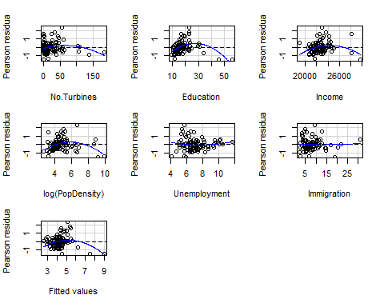

## Test stat Pr(>|Test stat|)   
## No.Turbines -2.2073 0.02995 *   
## Education -6.7091 1.975e-09 ***  
## Income -3.5585 0.00061 ***  
## log(PopDensity) -4.5733 1.600e-05 ***  
## Unemployment 0.9028 0.36915   
## Immigration 0.3484 0.72839   
## Tukey test -4.6936 2.685e-06 ***  
## ---  
## Signif. codes: 0 '***' 0.001 '**' 0.01 '*' 0.05 '.' 0.1 ' ' 1

ncvTest(m1) # test significant, there is a problem with non constant variance

## Non-constant Variance Score Test   
## Variance formula: ~ fitted.values   
## Chisquare = 26.11821, Df = 1, p = 3.2114e-07

##Residuals ##  
##2012  
m2<-lm(EELV~No.Turbines+ Education + Income+ log(PopDensity)+ Unemployment+ Immigration, data=df12)  
residualPlots(m2) # turkey test significant, problem

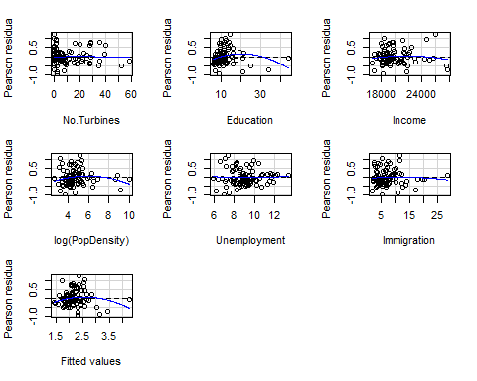

## Test stat Pr(>|Test stat|)   
## No.Turbines -0.1286 0.89799   
## Education -2.4466 0.01646 *  
## Income -0.9021 0.36950   
## log(PopDensity) -2.0285 0.04561 *  
## Unemployment 0.4058 0.68587   
## Immigration -0.6486 0.51832   
## Tukey test -2.3303 0.01979 *  
## ---  
## Signif. codes: 0 '***' 0.001 '**' 0.01 '*' 0.05 '.' 0.1 ' ' 1

ncvTest(m2) # significant, problem

## Non-constant Variance Score Test   
## Variance formula: ~ fitted.values   
## Chisquare = 4.932104, Df = 1, p = 0.026362

##Normality, outliers and influencial data   
##2022  
plot(density(rstudent(m1))) ## left and right hand tails longer than they should be

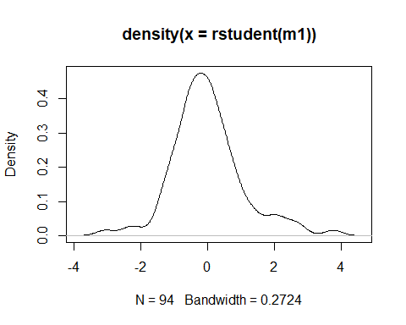

qqPlot(m1) # there are outliers

## Warning in rlm.default(x, y, weights, method = method, wt.method = wt.method, :  
## 'rlm' failed to converge in 20 steps

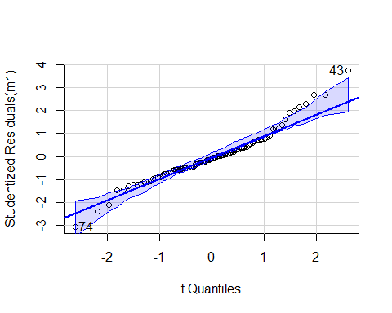

## [1] 43 74

outlierTest(m1) # evidence of outliers

## rstudent unadjusted p-value Bonferroni p  
## 43 3.758372 0.00031088 0.029223

#2012   
plot(density(rstudent(m2))) ## left hand side tail slightly longer than it should be

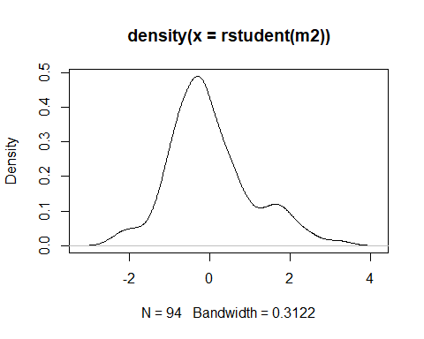

qqPlot(m2) # outliers

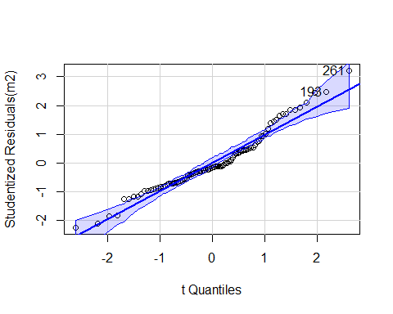

## 193 261   
## 5 73

outlierTest(m2) # unadjusted p-value, less than p<0.05, and bonferroni p larger than 0.05

## No Studentized residuals with Bonferroni p < 0.05  
## Largest |rstudent|:  
## rstudent unadjusted p-value Bonferroni p  
## 261 3.216797 0.0018277 0.17181